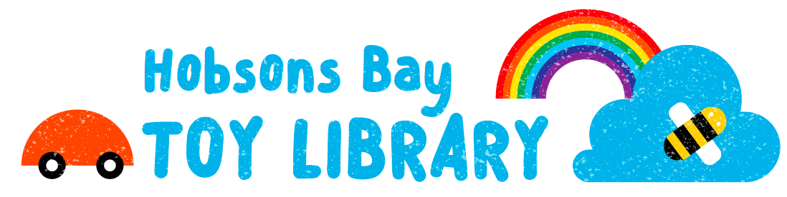

Hobsons Bay Toy Library
51 Maddox Road
Newport VIC 3015
ABN: 43 430 559 352
www.hobsonsbaytoylibrary.org.au
Find us on Facebook: www.fb.com/hobsonsbaytoylibrary
Find us on Instagram: www.instagram.com/hobsonsbay_toy_library

HOBSONS BAY TOY LIBRARY DONATION GUIDELINES

Hobsons Bay Toy Library is a non-profit community run organisation. We rely on sponsorship, volunteering, grants and donations to keep the toy library running so we are very grateful for your contribution

What type of toys do we accept?

Below are some donation guidelines to help us avoid waste and duplication. These guidelines are updated periodically to reflect our current collection needs.

Please note: We are currently not accepting toys for children aged 3 months to 2 years as we have a surplus in this age range. As a rule of thumb, please only donate toys which you would be happy to give a friend

We will gladly accept pre-loved toys which meet the below requirements:

- All toys must be fully functional, clean and in good condition
- Toys must be complete with all parts
- Toys that are easy to clean (i.e. no soft toys or teddies)
- Toys that are durable and robust
- Where possible, toys with manuals if they require instructions to operate

Toys that we cannot accept include:

- Toys that are licensed e.g. Pepper Pig, PJ Masks, Paw Patrol etc.
- Remote control toys
- Toys not suitable for children under the age of 6 years
- Soft toys
- Toys that might be deemed hazardous for small children

How can you donate?

Please send an email to us at hobsonsbaytoylibrary@gmail.com with a description and photo of the toy if possible and our coordinators will let you know if the donation is suitable

